Examples of burn pile material—Clean wood with no paint, thinners, other hazardous coatings. (Wood pallets above and construction wood below). Far bottom: Compost pile example.  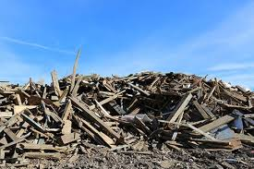  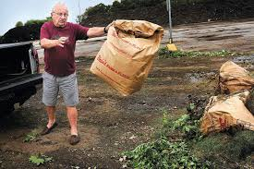 |  |  | City of Alma  Landfill  Location  The City of Alma Landfill is located off of C.T.H. I at S1551 Shawnee Drive. Coming from the south on State Road 35 you will make a right onto C.T.H. I and go approximately 1.25 miles and Shawnee Drive will be on your left. You will pass the Alma Memorial Cemetery and continue on Shawnee Drive. From the north on State Road 35 you would take a left onto C.T.H. I and then follow the same directions above.  Contact Us  If you need to contact the City for any landfill related question, please call the city garage at 608-685-3629 or City Hall at 608-685-3330.  Thank you for your cooperation with the landfill rules. Our landfill needs annual licensing from the DNR. All guidelines are derived from the stipulations of our DNR license.  Again Thank You.  Ag |  |  | New Rates and acceptable items  city of alma landfill  Phone: 608-685-4116  Dale Rieck, Landfill Attendant  - Open Fridays---9:00 a.m. to 3 p.m. Saturdays---9:00 a.m. to 1 p.m.

What do you include in a brochure?  Here are a couple of ideas…  This spot would be perfect for a mission statement. You might use the right side of the page to summarize how you stand out from the crowd and use the center for a brief success story.  (And be sure to pick photos that show off what your company does best. Pictures should always dress to impress.) |  |  | Think a document that looks this good has to be difficult to format?  Think again! We’ve created styles that let you match the formatting in this brochure with just a click. On the Home tab of the ribbon, check out the Styles gallery.  “Don’t be shy! Show them how fabulous you are! This is a great spot for a glowing testimonial.”  Get the exact results you want  To easily customize the look of this brochure, on the Design tab of the ribbon, check out the Themes, Colors, and Fonts galleries.  Have company-branded colors or fonts?  No problem! The Themes, Colors, and Fonts galleries give you the option to add your own. |  |  | [Type a caption for your photo]  Don’t forget to include some specifics about what you offer, and how you differ from the competition.  Our Products and Services  You could include a bulleted list of products, services, or major benefits of working with your company. Or just summarize your finer points in a few concise paragraphs.  We know you could go on for hours about how great your business is. (And we don’t blame you—you’re amazing!) Just remember that this is marketing—if you want to grab their attention, keep it brief, friendly, and readable.

