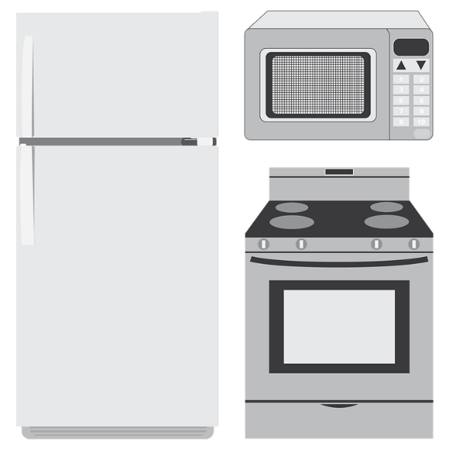

The City Maintenance Crew will make curbside pickup of LARGE ITEMS (appliances, furniture, etc.) for disposal at the demolition landfill on Wednesday, Nov. 1, 2017. The regular landfill charges per item will apply but no charge for hauling. please call the City Clerk’s Office between 8:00 AM to 4:30 PM, Monday, Wed. & Friday at 685-3330 with listing of the items to be disposed of before
Monday, October 30, 2017

